

CAP445:

Course Code: OBJECT ORIENTED PROGRAMMING USING C++ - LAB

**Submitted by**

**REG NO: 12013997**

**Roll no: 82**

**Submitted to**

**Kumar Vishal**

**LOVELY PROFESSIONAL UNIVERSITY**

in partial fulfilment of the requirements for the award of degree of

**Masters of Computer Application**

**QUESTION 1**

Write a program to implement the following: create a class representing a company where a company has a minimum and maximum limit of the quantity of products. Allow the user to order from the company product list (create a list of any ten products). Apply proper constraint if user order more than the quantity available with the company. Based on the quantity generate the customer bill. Use the concept of operator overloading in generating bill.

**ANSWER**

#include <iostream>

using namespace std;

class KAKA {

private:

int no_product, price; //there we have integer product and price ;

public:

KAKA(int n = 0, int p =0)

{no_product = n; price = p;}

KAKA operator + (KAKA const &obj) { //concept of operator overloading with const

KAKA res;

res.no_product = no_product + obj.no_product;

res.price = price + obj.price;

return res;

}

void print()

{

cout <<"Total customer bill="<< no_product + price << endl;//now it will print the total bill

}

};

int main()

{

int size1;

cout<<" minimum=5 and maximum=10 limit products"<<endl;

cout<<"click '1' for minimum '2' for maximum products "<<endl;

cin>>size1;

cout<<"0:HP(500$) 1:LG(100$) 2:HP(120$) 3:LG(400$)4:02(20$) 5:PLAM(200$) 6:WIKO(100$) 7:ZTE(500$) 8:IBOOK(900$) 9:PANASONIC(20$)"<<endl;

if(size1==1)//minimum is 5 items if user enter the 1

{

int product[10]={500,100,120,400,20,200,100,500,900,20}; //array use for price of items index use for accessing the product price

int a,b,c,d,e,m;

cout<<"enter the number of products '0' to '10'"<<endl; //user enter the index number to access the price of items in array

cin>>a;

cin>>b;

cin>>c;

cin>>d;

cin>>e;

KAKA c1(product[a], product[b]), c2(product[c], product[d]),c3(product[e]);//

KAKA c4 = c1+ c2+c3;

c4.print();

}

if(size1==2)//there user chose to select the 10 items form the array

{

int product[10]={500,100,120,400,20,200,100,500,900,20};

int a,b,c,d,e,f,g,h,i,j;

cout<<"every products has number start from '0' up '10' "<<endl;

cin>>a;

cin>>b;

cin>>c;

cin>>d;

cin>>e;

cin>>f;

cin>>g;

cin>>h;

cin>>i;

cin>>j;

KAKA

c1(product[a], product[b]),

c2(product[c], product[d]),

c3(product[e],product[f]),

c4(product[g],product[h]),

c5(product[i],product[j]);

KAKA c6 = c1+ c2+c3+c4+c5;

c6.print();//

}

}

**OUTPUT**

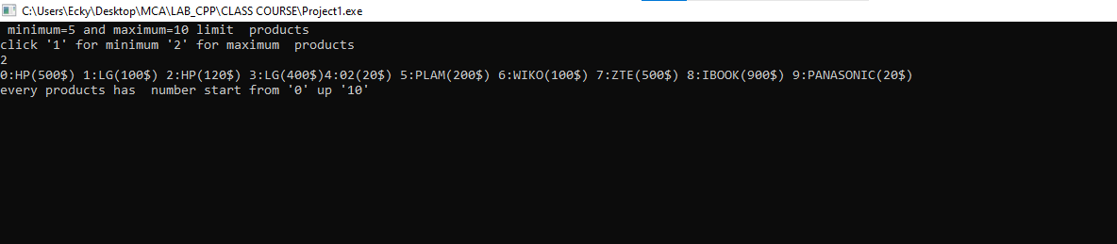

**QUESTION 2**

You have to generate electricity bill for a customer with the details as give below: Customer ID, Customer Name, Customer Address, Contact No, Units Consumed, Total payable amount Following are the norms to calculate the unit amount: a) for initial 100 units it will cost 6rpu b) for next 100 units it will cost 8rpu c) for next all units it will cost 10rpu. Implement the concept of hybrid inheritance in this program.

**ANSWER**

#include <iostream>

using namespace std;

class customer

{

public:

string name;

void input(string n)

{

name=n;

}

void output()

{

cout<<"name : "<<name<<endl;

}

};

class details:public customer

{

public:

int id;

string address;

int number;

void input_d(int i,string a,int n1)

{

id=i;

address=a;

number=n1;

}

void output_d()

{

cout<<"customer ID is :"<<id<<endl;

cout<<"customer address is : "<<address<<endl;

cout<<"customer number is : "<<number<<endl;

}

};

class Units

{

public:

float unit;

void input_u(float u)

{

unit=u;

}

void output_u()

{

cout<<"The total units used by customer is = "<<unit<<endl;

}

};

class result:public details,public Units

{

public:

float total;

void output_r()

{

if(unit<=100)

{

total=unit*6;

cout<<"first 100 unit bill is : "<<total<<endl;

}

else if(unit>100 && unit<200)

{

total=unit*8;

cout<<"next 100 units bill is : "<<total<<endl;

}

else if(unit>200)

{

total=unit*10;

cout<<"next all units cost is : "<<total<<endl;

}

output();

output_d();

output_u();

}

};

int main()

{

string name;

int id;

string address;

int number;

float unit;

cout<<"enter the name of customer :"<<endl;

cin>>name;

cout<<"enter the id of customer:"<<endl;

cin>>id;

cout<<"enter the address of customer :"<<endl;

cin>>address;

cout<<"enter the total units used by customer :"<<endl;

cin>>unit;

result a;

a.input(name);

a.input_d(id,address,number);

a.input_u(unit);

a.output_r();

}

**OUTPUT**

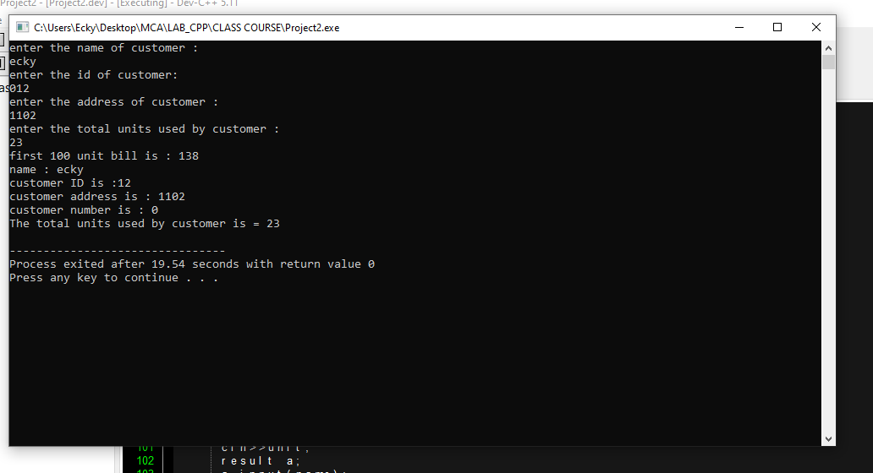

**QUESTION 3**

Suppose a customer having accounts in three different branches in Jalandhar, Phagwara and Hoshiarpur etc. Customer want to know about the detail of balance from all branches and also want to know branch name in which customer having more balance. Write a program using the concept of inheritance.

**ANSWER**

#include <iostream>

using namespace std;

class sinza

{

public:

float balance_j=5000;

void branch_j()

{

cout<<"sinza branch balance ="<<balance_j<<endl;

}

};

class mtwara

{

public:

float balance_p=4000;

void branch_p()

{

cout<<"mtwara branch balance ="<<balance_p<<endl;

}

};

class dar

{

public:

float balance_h=100000;

void branch_h()

{

cout<<"darr branch balance ="<<balance_h<<endl;

}};

class all_branch:public sinza,public mtwara,public dar

{

public:

void show()

{

branch_j();

branch_p();

branch_h();

if(balance_j<balance_p && balance_h<balance_p)

{

cout<<"customer having more balance in mtwara branch then all="<<balance_p<<endl;

}

else if(balance_p<balance_j && balance_h<balance_j)

{

cout<<"customer having more balance in sinza branch then all="<<balance_j<<endl;

}

else if(balance_j<balance_h && balance_p<balance_h)

{

cout<<"customer having more balance is In darr branch then all branchs is= "<<balance_h<<endl;

} }

};

int main()

{

all_branch a;

a.show();

}

**OUTPUT**